It is very important that only good quality school supplies be purchased for the next school year. We request that “dollar store” supplies NOT be brought to school, as they are not suitable for classroom use. Please ensure you purchase all the supplies as they are needed for a smooth start for the new year. All items must be individually labelled.

SUPPLIES
Quantity | Item | Check ✓
2 pkg. | Lined paper refills (200 sheets)
50 | Sheets graph paper (1 cm squares)
10 | Duo tangs (different colours)
1 | Ruler – 30cm/mm (rigid, not floppy)
1 pkg. | Pencil crayons (24) – sharpened (Laurentien, Crayola or Prang)
20 | HB pencils – sharpened; OR mechanical pencils 0.5mm or 0.7mm lead size – labelled with name
5 | 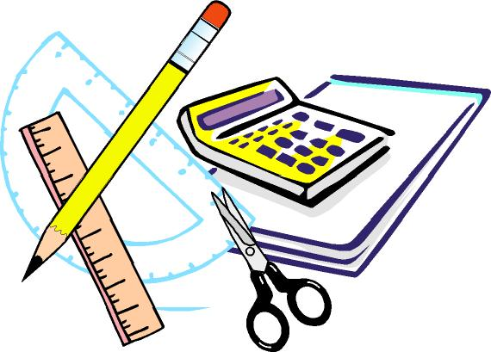  Pens, medium blue (Papermate)
2 | Pens medium red (Papermate)
5-6 | Sharpies – fine black
5-6 | Sharpies – ultra fine
1 | Plastic Pencil box – 8” x 5”
4 | White vinyl large erasers
1 box | Facial tissues (100)
1 | Solar calculator
1 pr. | Scissors
1 box | Crayola Crayons (24)
1 | Pencil Sharpener (with holder for shavings)
4 | Glue Sticks (large)
1 pkg. | Felt Pens
12 | Dry Erase Markers and 1 white board eraser
6 | Highlighters, different colours
1 pair | Earbuds (optional)
1 | 1” 3 Ring Binder
1 | Set of 8 dividers
1 | Water Bottle
1 | Personal size hand sanitizer
1 | Clipboard (cover recommended)

Please label all individual supplies and clothing. Please remember that supplies will need to be replaced periodically.

This is a basic supply list. Some teachers may have extra specific items which will be requested in September.

GYM CLOTHING – TO BE KEPT AT SCHOOL – appropriate for outside P.E. class
Quantity | Item | Check ✓
1 pr. | Running shoes – non-marking soles
1 pr. | Socks
1 pr. | Gym shorts
1 | T-shirt
1 | Sweatshirt
1 | Cloth bag to hold clothing

