Attached below is a list of school supplies that are requested for the 2023-2024 school year. Please ensure you purchase all the supplies as they are needed for a smooth start for the new year. All items must be individually labelled. Thank you.

SUPPLIES
Quantity | Item | Check ✓
2 pkg. | Lined paper refills (200 sheets)
12 | Duo tangs (different colours)
1 | Ruler – 30cm/mm (rigid, not floppy)
1 pkg. | Pencil crayons (24) – sharpened (Laurentien, Crayola or Prang)
20 | HB pencils – sharpened; OR mechanical pencils 0.5mm or 0.7mm lead size – labelled with name
5 | 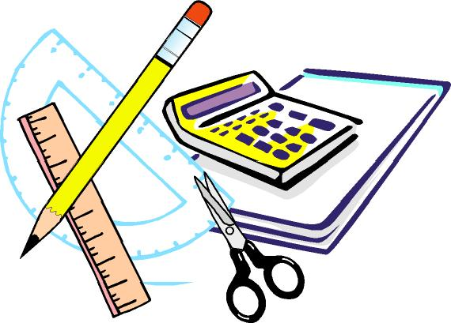  Pens, medium blue (Papermate)
2 | Pens medium red (Papermate)
5-6 | Sharpies – fine black
5-6 | Sharpies – ultra fine
1 | Plastic Pencil box – 8” x 5”
4 | White vinyl large erasers
1 box | Facial tissues (100)
1 | Solar calculator
1 pr. | Scissors
1 box | Crayola Crayons (24)
1 | Pencil Sharpener (with holder for shavings)
4 | Glue Sticks
1 pkg. | Felt Pens (10)
10 | Dry Erase Markers and 1 white board eraser
6 | Highlighters, different colours
1 pair | Earbuds (optional)
1 | Water Bottle
1 | Personal size hand sanitizer
1 | Clipboard (cover recommended)

Please label all individual supplies and clothing. Please remember that supplies will need to be replaced periodically.

This is a basic supply list. Some teachers may have extra specific items which will be requested in September.

GYM CLOTHING – TO BE KEPT AT SCHOOL – appropriate for outside P.E. class
Quantity | Item | Check ✓
1 pr. | Running shoes – non-marking soles
1 pr. | Socks
1 pr. | Gym shorts
1 | T-shirt
1 | Sweatshirt
1 | Cloth bag to hold clothing

